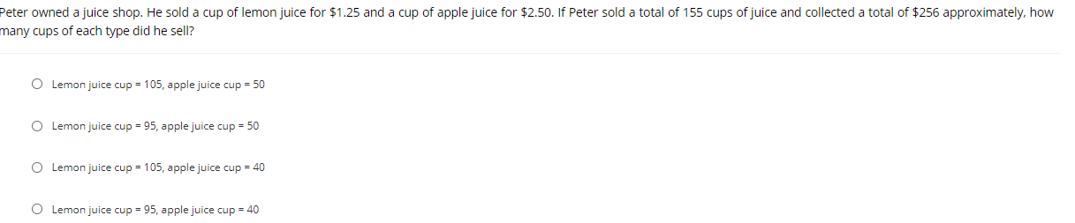
A (lemon juice cup = 105, apple juice cup =50)
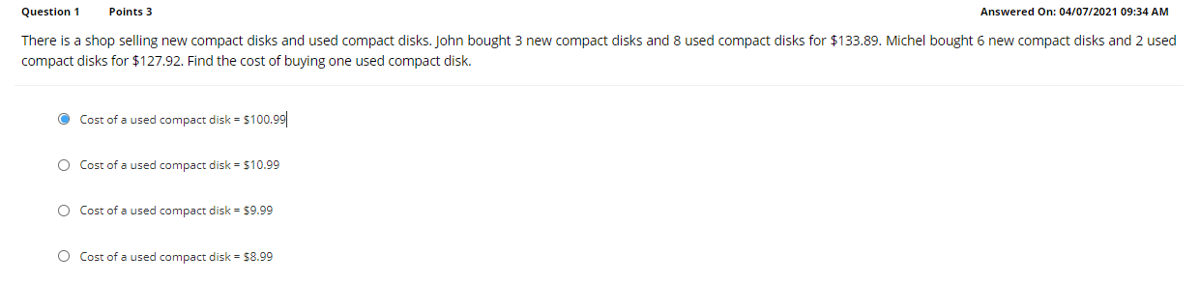C (cost of a used compact disk =$9.99)
A (y+8x=139)

C (2, -1)
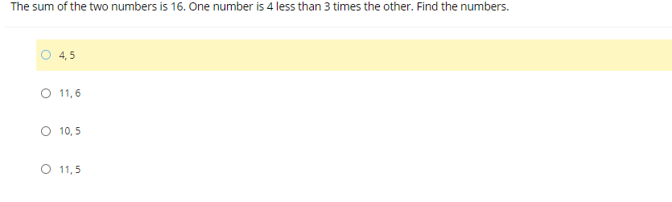
D (11,5)

A (8)
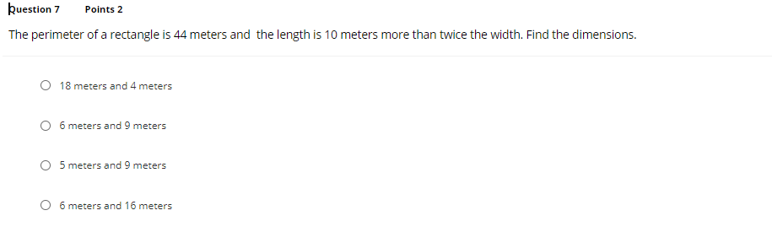
D (6 meters and 16 meters)
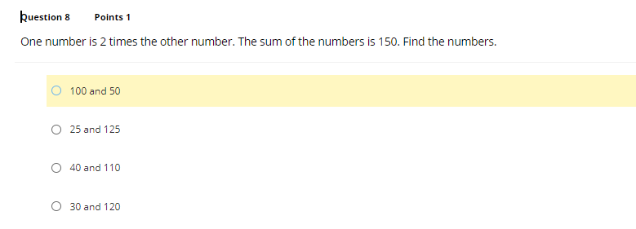
A (100 and 50)
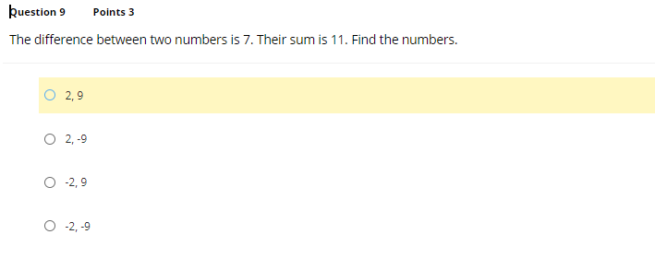
A (2,9)


B (pizza)
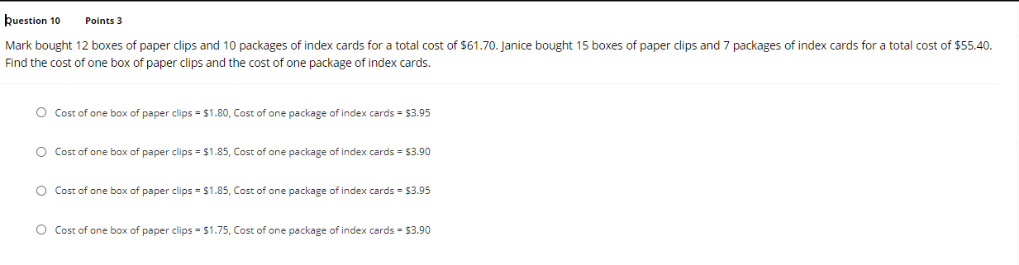
C (cost of one box of paper clips=$1.85, cost of one package of index cards=$3.95)

D (20 cent)
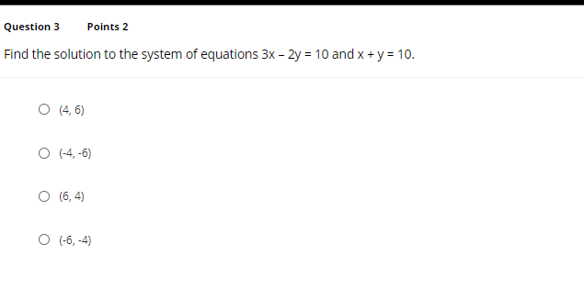
C (6,4)
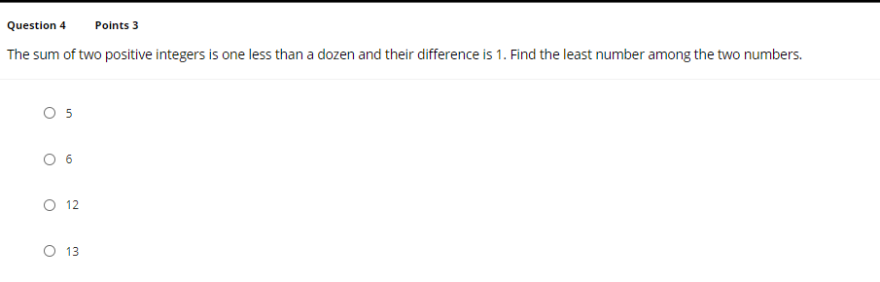
A (5)

B (No solution)

B (-10,35)
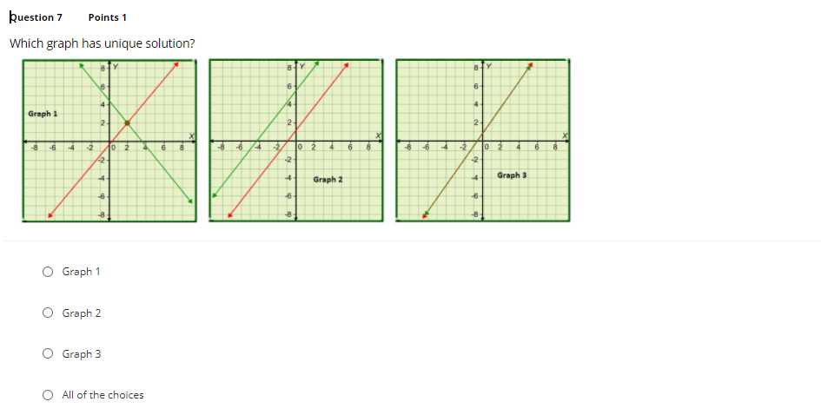
A (graph 1)


A (8 cents)


B (unique)
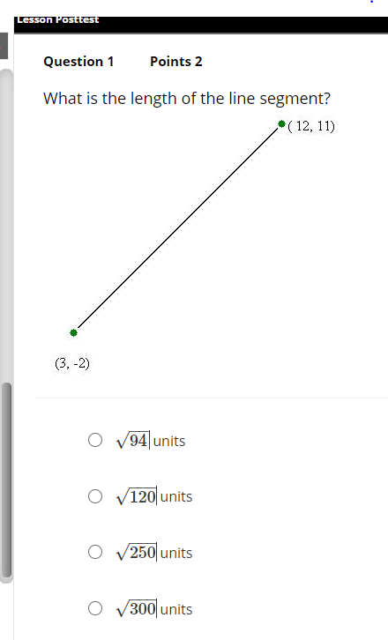
C ($\sqrt{250}$) units
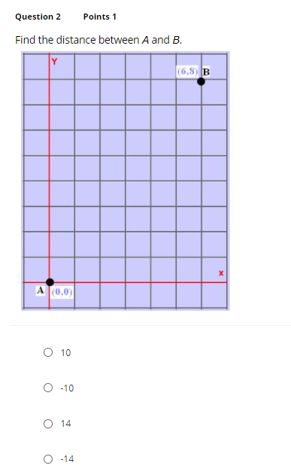
A (10)

C (3)
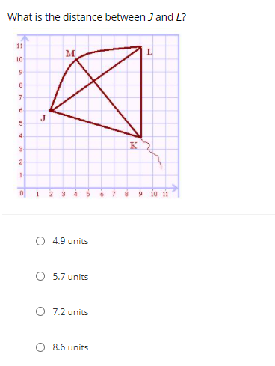
D (8.6)
D (8.6 units)
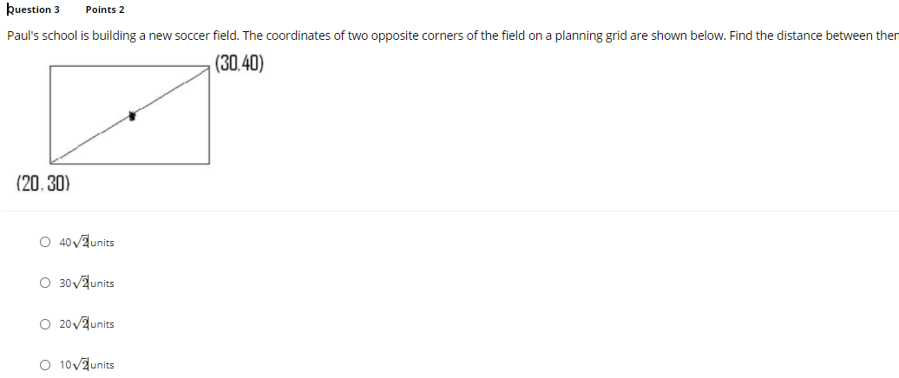
D ( $10\sqrt{2}$)
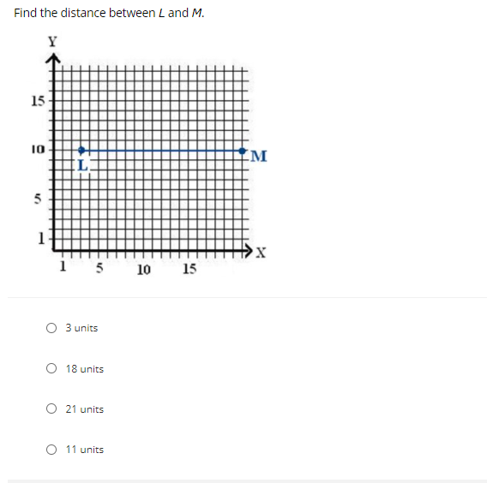
B (18 units)

B (5 )

